LISTENING TO THE SOUND OF BIRDS AT SUNSET

Ali NEVI¹, Shak ORSAN², Sema URLA³

¹Department of Computer-Integrated Technologies, Automation and Mechatronics, Faculty of Automatics and Computerized Technologies, Uzbekistan
^{2,3}Physics Department, Faculty of Science, Bilecik, Türkiye

ABSTRACT
The reason we really appreciate the sunset may be the same reason introverts look so natural. That's the beauty of being able to appreciate peace and quiet. Introverts are seen as people who do not like to socialize. However, they do not hate parties or entertainment, they simply see them as barriers to communication.

Introverts don't consider time spent eating a good dinner and watching a good movie on TV as wasted. On the contrary, they see such nights as a necessity. It's a fun time they enjoy before they go out into the world again. We can say that about a third of the population is introverted.
Keywords: Lidar, ROS, odometry, cloud server.

1. INTRODUCTION
The reason we really appreciate the sunset may be the same reason introverts look so natural. That's the beauty of being able to appreciate peace and quiet. Introverts are seen as people who do not like to socialize. However, they do not hate parties or entertainment, they simply see them as barriers to communication [1].

Introverts don't consider time spent eating a good dinner and watching a good movie on TV as wasted. On the contrary, they see such nights as a necessity. It's a fun time they enjoy before they go out into the world again. We can say that about a third of the population is introverted.

2. DEVELOPMENT OF A NAVIGATION SYSTEM FOR MAP BUILDING
The reason we really appreciate the sunset may be the same reason introverts look so natural. That's the beauty of being able to appreciate peace and quiet. Introverts are seen as people who do not like to socialize [2]. However, they do not hate parties or entertainment, they simply see them as barriers to communication.

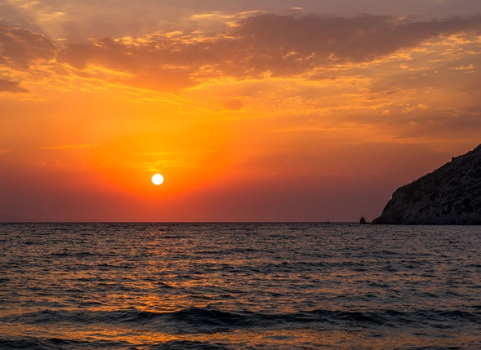
Figure 1. Example of a constructed room map

Introverts don't consider time spent eating a good dinner and watching a good movie on TV as wasted. On the contrary, they see such nights as a necessity. It's a fun time they enjoy before they go out into the world again. We can say that about a third of the population is introverted.

(1)
Table 1. Sunset Time
 | Ankara | Van
1st June | 20.00 | 19.30
2nd June | 20.01 | 19.31

From the example, you can see that the scanning distance increases sequentially from the minimum to the maximum value. In the process of scanning, the angle of rotation of the sensor changes sequentially from zero to 360 degrees. If for the given angle an obstacle is found, the distance to it and the angle of rotation are memorized. At the next scanning radius, this angle is no longer used to reduce the time of this procedure.
A=B+C (1)
C=E-H (2)

3. CONCLUSION
Thus, this paper presents the results of research in the field of navigation of mobile robots, the proposed technology of navigation of a group of robots using a cloud service with the use of a single server designed to collect information from sensors of robotic equipment and use it to build a map of the working space. An example of a constructed map of a room using sensors of a mobile robot is given. An example of a possible design of a mobile workplace used to build a map of the area is given. The structural diagram of the cloud data storage for the construction of the terrain map is developed [4]. The structure of the data collection server is developed and the algorithm of the mobile platform in interaction with the cloud server is proposed. The developed application performs the following functions: displaying the list of mobile devices registered on the server; displaying the room plan; generating the ground map based on the data from the cloud storage; accumulating information about the environment of the mobile platform to build a ground map.

REFERENCES
[1] Nevludov I. Production workspace obstacle avoidance mobile robot trajectory modeling. I. Nevludov, S. Novoselov, O. Sychova, S. Tesliuk. Computer and information systems and technologies. 2021. pp. 61-62.

[2] Novoselov S. Development of the method local navigation of mobile robot a based on the tags with QR code and wireless sensor network. S. Novoselov, O. Sychova, S. Tesliuk. 2019 IEEE XVth International Conference on the Perspective Technologies and Methods in MEMS Design (MEMSTECH). 2019. pp. 45-51.

[3] Pﬁngsthorn, M. and Birk, A. Generalized Graph SLAM: Solving Local and Global Ambi-guities through Multimodal and Hyperedge Constraints. The International Journal of Robotics Research. In Press (2015).

[4] Agarwal, P., Tipaldi, G., Spinello, L., Stachniss, C., and Burgard, W. Robust mapoptimization using dynamic covariance scaling, in Robotics and Automation (ICRA), 2013 IEEE International Conference on, pp. 62–69,

