AN AUTOMATED SYSTEM FOR SORTING SMD COMPONENTS AS A TOOL TO SUPPORT THE CIRCULAR ECONOMY THROUGH THE REUSE OF
RADIO COMPONENTS

Igor NEVLIUDOV¹, Serhii NOVOSELOV¹, Oksana SYCHOVA¹,
Serhii TESLIUK¹

¹Department of Computer-İntegrated Technologies, Automation and Robotics, Faculty of Automatics and Computerized Technologies, Kharkiv National University of Radio Electronics, Kharkiv, Ukraine

ABSTRACT
The paper describes an automated system for sorting SMD components. The architecture of the automated system is presented, the structure of the SMD component dosing module and their feeding to the conveyor line for sorting is proposed. A feature of the proposed solution is the use of instruments for measuring the nominal value of the radio component directly in the dosing module before entering the module for moving them to the robotic manipulator.
A functional diagram of the automated system and a sketch of the SMD component dosing module layout are presented. A description of the algorithm for the operation of the automated SMD component sorting system is given. The proposed solution will allow to increase production efficiency by reusing radio components.
The problem solved in this paper corresponds to the goals of sustainable development, namely the goal of sustainable development No. 12 "Responsible consumption and production".

Keywords: algorithm, automated system, dosing module, SMD component, sorting system.

1. INTRODUCTION
The rapid pace of industrial development and the growth of consumer needs lead to the constant renewal of electronics, which leads to significant depletion of natural resources and the accumulation of large amounts of waste, among which electronic components occupy a special place [1-2]. Due to the relatively shorter lifespan of household appliances compared to industrial equipment and the rapid growth of new generations of electronics products, used electronic equipment is discarded in large quantities every year. Since e-waste can contain a lot of reusable components, valuable materials, and toxic substances, its recycling is cost-effective and environmentally friendly [1-3].
One strategy in the circular economy is to reuse critical or rare materials in order to reduce the material resources used in production [4].
Reusing radio components has several important advantages. First, it helps to conserve resources, as it minimizes the need to extract new raw materials used in the production of electronic components, such as metals, rare earth elements and plastics. Second, this approach helps to reduce the volume of electronic waste, which often contains toxic substances and creates a significant environmental burden if improperly disposed of. Third, reuse contributes to the development of a closed-loop economy, where products and materials retain their value for as long as possible.
Reusing radio components is a necessary condition for the practical implementation of Sustainable Development Goal No. 12 "Responsible Consumption and Production" [5]. This allows not only to use resources more rationally and reduce waste, but also to form a new ethic of production and consumption, focused on long-term sustainability and environmental preservation for future generations.
This paper proposes a method for automating the sorting of SMD components when they are reused in production. The structure of the automated device is proposed and the principle of operation of the software and hardware is described.
2. ARCHITECTURE OF AN AUTOMATED SYSTEM FOR SORTING RADIO COMPONENTS AT THE PRODUCTION SITE
The architecture of an automated SMD component sorting system is shown in Figure 1.

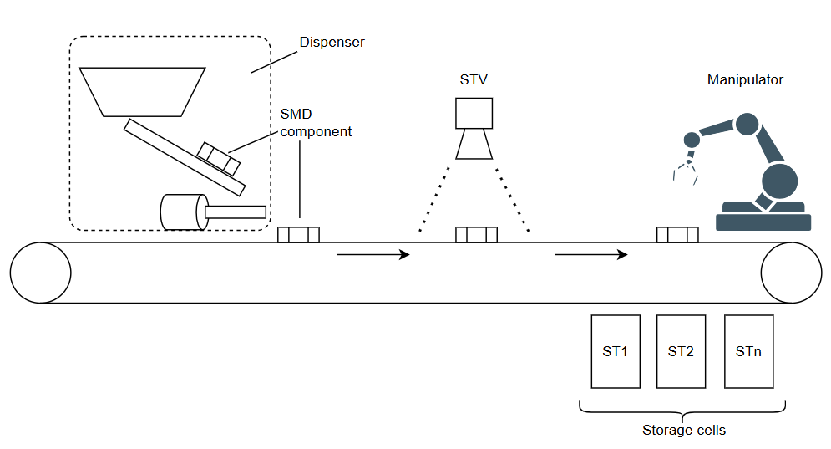
Figure 1. Architecture of an automated SMD component sorting system

The automated system includes:
– SMD component dispenser;
– conveyor line;
– a system of technical vision;
– robot manipulator;
– a set of cells for storing sorted radio elements.
The SMD component dispenser has a hopper where radio elements are poured after they are removed from the printed circuit board for reuse, or those that were rejected during the automated soldering process. The dispenser feeds the radio elements to the conveyor line and ensures their uniform and controlled supply. The conveyor line transports SMD components along the working area of the system, ensuring their gradual movement to the next processing stages. A technical vision system (STV) is installed above the conveyor, which performs visual identification of components, determining their type, orientation, and, if necessary, their condition. The technical vision system transmits the collected information to the controller, which forms a task for the next stage. Next, the robot manipulator captures components from the conveyor belt according to the data received from the vision system [6]. The manipulator moves each element to the appropriate cell for storage. A set of storage cells, designated in the figure as ST1, ST2, ..., STn, is designed to distribute components by type or other characteristics, thus completing the sorting process and ensuring convenient further use of these radioelements [7-8].
Figure 2 shows the functionality of the SMD component dispenser. The diagram shows that the dispenser control unit processes signals from the IR sensor for the presence of an SMD component in the measurement area and information coming from a resistance or capacitance meter.
The entire module is authorized to operate by a decision-making unit based on data received from the radio element parameter measurement module. The SMD component enters the measurement area under the action of vibration effects provided by an auxiliary motor (not shown in this diagram).
After determining the presence of an SMD component, the electromagnet should turn on, which will press the measuring probes to the component for a time T, which is determined by the timer. During this time, the measurement module must make the necessary calculations and determine the nominal value of the part. Depending on this value, the component will be moved to the corresponding storage cell. This operation is performed by another module – the component transportation module.

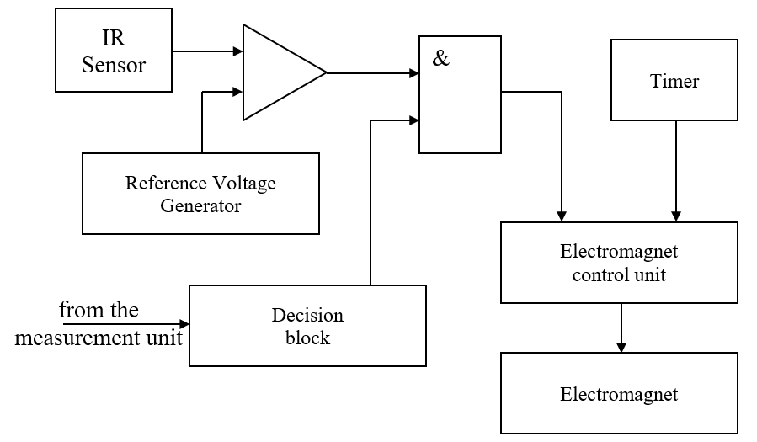
Figure 2. Functional diagram of the automated system

Figure 3 shows a block diagram of a SMD component dispensing device.

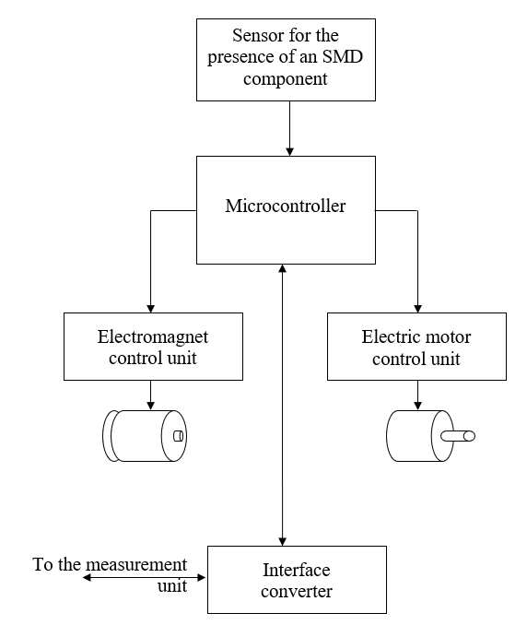
Figure 3. Structural diagram of the SMD component dispensing device

The above figure shows that the system consists of five main blocks:
– SMD component presence sensor;
– microcontroller;
– electromagnet control unit;
– motor control unit;
– interface converter.
The microcontroller combines the functions of a decision-making unit, a timer, a comparator and an adder. An optical pair – an IR LED and a photodiode – was chosen as a sensor for the presence of an SMD component. The motor control unit is necessary to match the motor supply voltage with the low-voltage voltage at the microcontroller output. Usually, such an element is a powerful field-effect or bipolar transistor connected according to a key circuit. The electromagnet control unit performs a similar task and has a similar schematic solution. Based on the analysis of existing solutions used in the design of component sorting modules in production, the following design of a vibrating tray was proposed (Fig. 4 and Fig. 5).

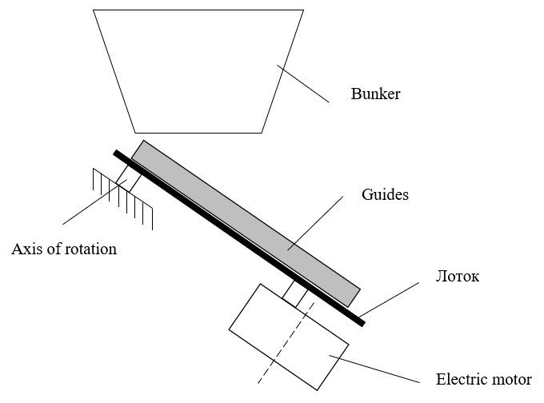
Figure 4. Layout diagram of the SMD component dispensing module (side view)

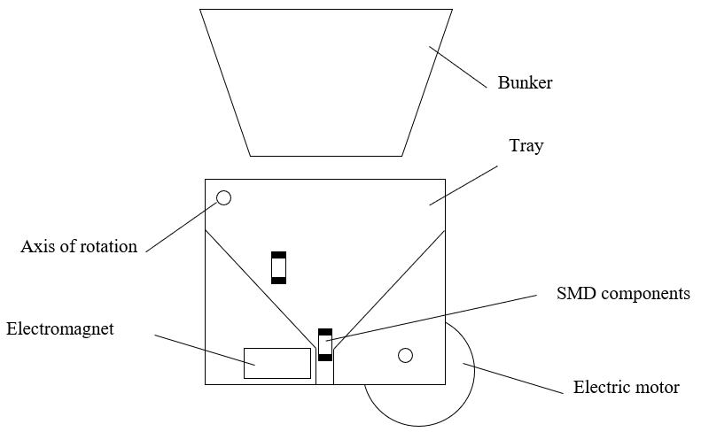
Figure 5. Layout diagram of the SMD component dispensing module (front view)

From the SMD hopper, components enter a tray equipped with inclined walls. The tray itself is also located at an angle of 45 degrees. to the horizontal surface. Under the action of gravity, as well as longitudinal vibration, SMD components fall down.
As can be seen from the sketch above, at the bottom of the tray the walls narrow to the calibration channel. Due to this, the components are aligned, oriented and lined up in one line. In this position, it is convenient to carry out measurements.
An electromagnet, which is also located on the tray, presses the measuring probes to the element, and the control module sends a signal to the measurement module. After the measurement is completed, the SMD component is released, and it enters the conveyor for transportation, orientation recognition for further movement to the desired cell using a robotic manipulator.
Figure 6 shows the algorithm of operation of the automated SMD component sorting system.

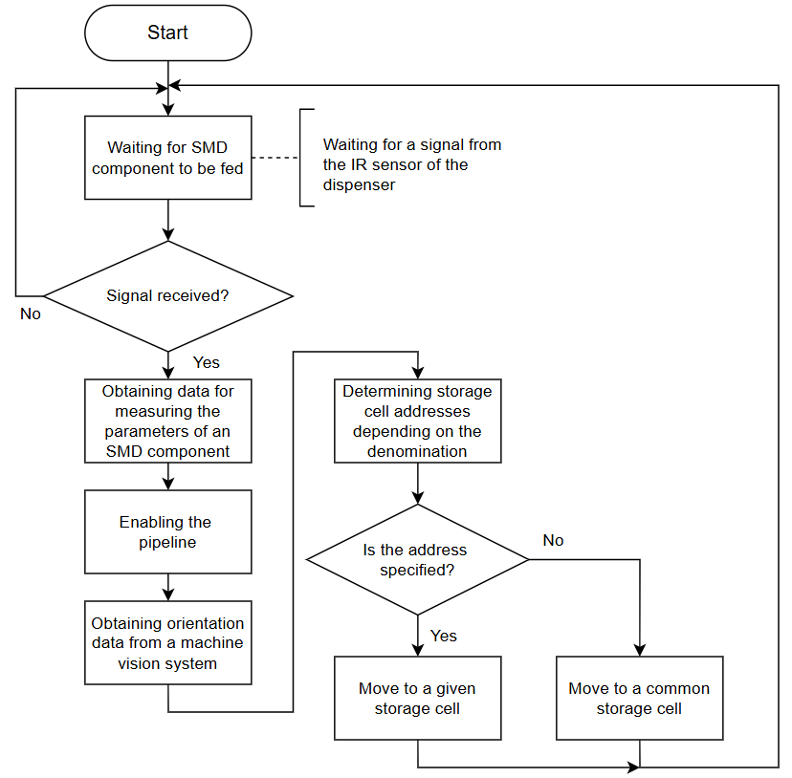
Figure 6. Algorithm of operation of the automated SMD component sorting system

The algorithm of the automated SMD component sorting system starts with waiting for the component to be supplied. The system is in a state of waiting for a signal from the infrared sensor installed in the dispenser. If the signal about the presence of the component is not received, the system continues to wait. After receiving the signal, the system proceeds to reading data from the SMD component parameters measurement unit. This information is needed to determine the required storage cell.
Next, the conveyor line is activated, which transports the component from the dispenser to the area of the vision system. The machine vision system is used to determine the orientation of the SMD component. As a result, the collected information allows you to determine the component value, which is used to determine the address of the corresponding storage cell and the current orientation for the correct positioning of the working body of the robotic manipulator [8-9].
Based on the received value, the system checks whether the required storage cell address is available to move this type of component to it. If the address is determined, the robot manipulator transports the component to the corresponding cell. If the address is not determined, the component is moved to a common cell for storage and subsequent re-sorting. After the operation is completed, the system returns to the initial state of waiting for the next component, and the cycle repeats [10].

3. CONCLUSION
Thus, this paper presents the results of a study on the topical topic of radio component reuse. This problem corresponds to the goals of sustainable development, namely the goal of sustainable development No. 12 "Responsible consumption and production". The paper describes an automated system for sorting SMD components. The architecture of the automated system is presented, the structure of the module for dosing SMD components and their feeding to the conveyor line for sorting is proposed. A feature of the proposed solution is the use of instruments for measuring the nominal value of the radio component directly in the dosing module before entering the module for moving them to the robotic manipulator. A functional diagram of the automated system and a sketch of the layout of the SMD component dosing module are presented. A description of the algorithm of the automated system for sorting SMD components is provided. The technical vision system is used to finally determine the parameters of the radio component and make a decision on moving it to the desired storage cell. The proposed solution will allow to increase production efficiency by reusing radio components.

REFERENCES
[1] Li Wei, Esders Bernhard, Breier Matthias. (2013). SMD segmentation for automated PCB recycling. IEEE International Conference on Industrial Informatics (INDIN). pp. 65-70. doi:10.1109/INDIN.2013.6622859.
[2] Katti Shubhangi, Kulkarni Nirmal. (2021). Automated sorting of used electronic components. AIP Conference Proceedings. 2335. 050004. doi:10.1063/5.0046374.
[3] Puttero Stefano, Nassehi Aydin, Verna Elisa, Genta Gianfranco, Galetto Maurizio. (2024). Automatic object detection for disassembly and recycling of electronic board components. Procedia CIRP. 127. pp. 206-211. doi:10.1016/j.procir.2024.07.036.
[4] Ricard Lykke, Folkmann Emilie, Sørensen Lars, Hybel Sofie, Nóbrega Roberto, Petersen Henrik. (2024). Design for robotic disassembly. Proceedings of the Design Society. 4. pp. 2715-2724. doi:10.1017/pds.2024.274.
[5] Goal 12: Responsible consumption and production – The Global Goals.
URL: https://www.globalgoals.org/goals/12-responsible-consumption-and-production/ (date of access: 06.05.2025).
[6] Nevliudov Igor, Novoselov Sergii, Sychova Oksana. (2022). Development and study of the operation of the module for determining the orientation of the manipulator joint. Innovative Technologies and Scientific Solutions for Industries. pp. 86-96. doi:10.30837/ITSSI.2022.20.086.
[7] Novoselov Sergii, Sychova Oksana. (2023). Digital Twin of the Educational Equipment "Sorting Station". pp. 11-14. doi:10.35598/mcfpga.2023.002.
[8] Novoselov Sergii, Sychova Oksana, Tesliuk Serhii. (2022). Multiflowed software motion control technology for a two-link manipulator with four degrees of freedom. doi:10.30837/MMP.2022.151.
[9] Nevliudov Igor, Novoselov Sergii, Klymenko Oleksandr, Vzhesnievskyi Maksym. (2023). Software implementation of the conveyor digital twin of the technological line. doi:10.30837/MMP.2023.240.
[10] Nevliudov Igor, Novoselov Sergii, Sychova Oksana, Mospan Denis. (2022). Multithreaded Software Control of Industrial Manipulator Movement. pp. 1-6. doi:10.1109/MEES58014.2022.10005675.

